**Appendix 10**. Contextualization of the VIIRS night-time lights analysis. We found a distinct threshold at a radiance value of ~ 80 (Figure 4 main manuscript).

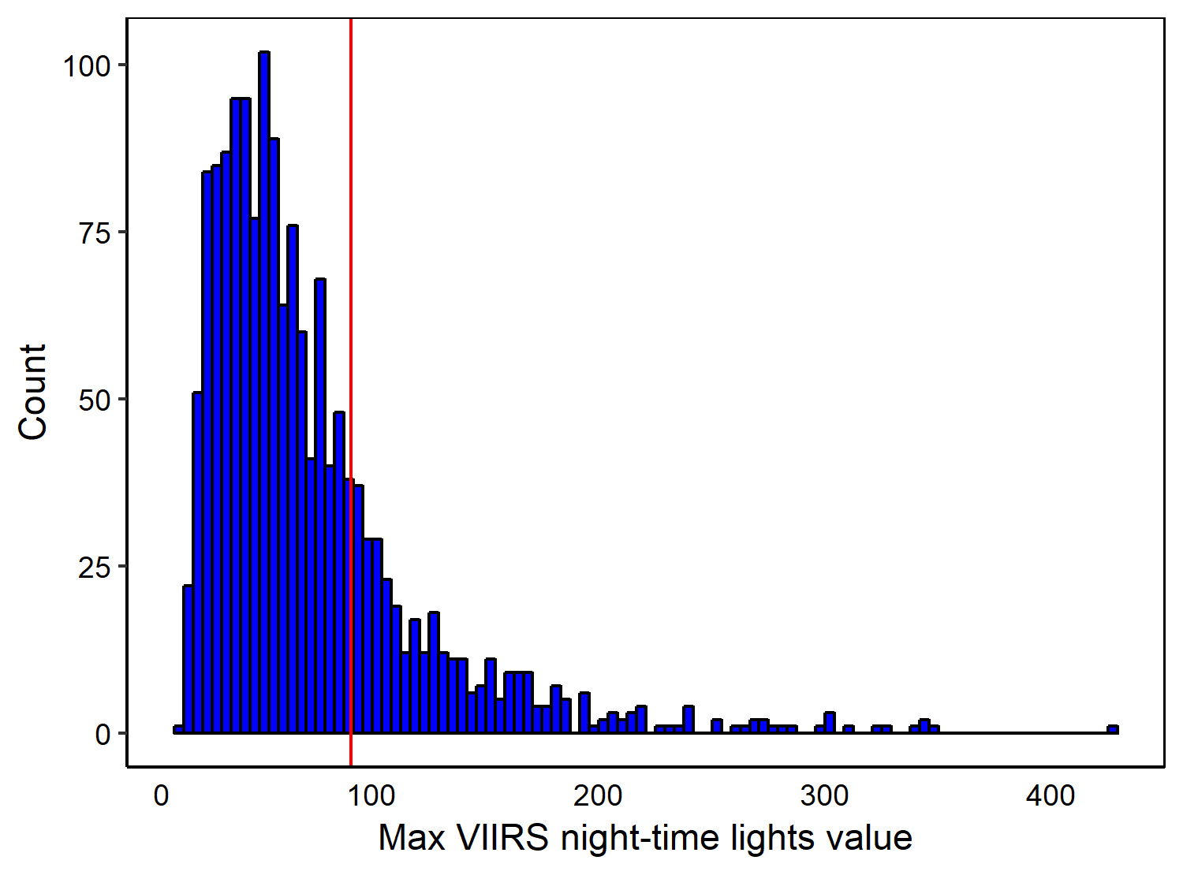

**Figure A1**. Histogram showing the distribution of maximum VIIRS night-time light values for the 1,581 cities included in the analysis: 363 (23%) of cities reached a maximum > 80 (the red line), which represents a threshold of biodiversity response to urbanization.

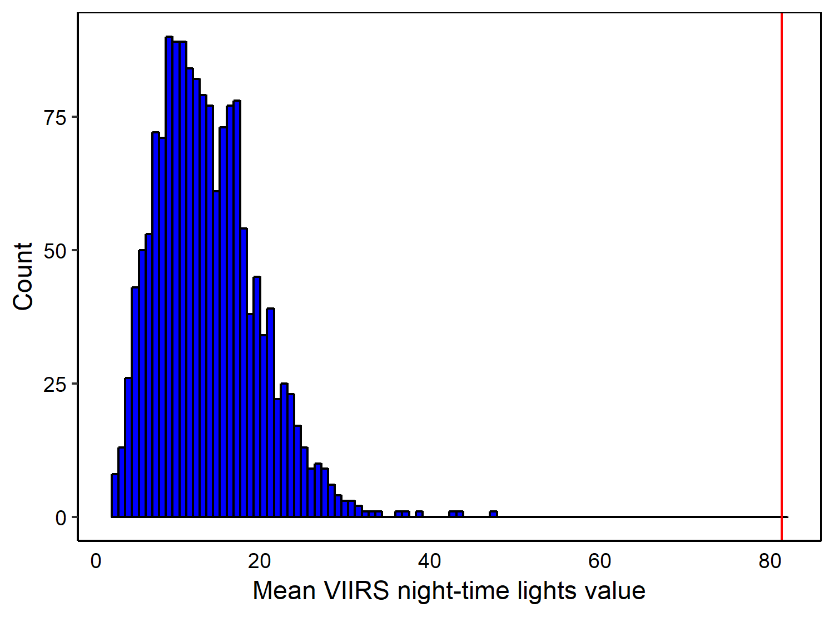

**Figure A2**. Histogram showing the distribution of mean VIIRS night-time light values for the 1,581 cities included in the analysis:0 cities have a mean > 80 (the red line), which represents a threshold of biodiversity response to urbanization.

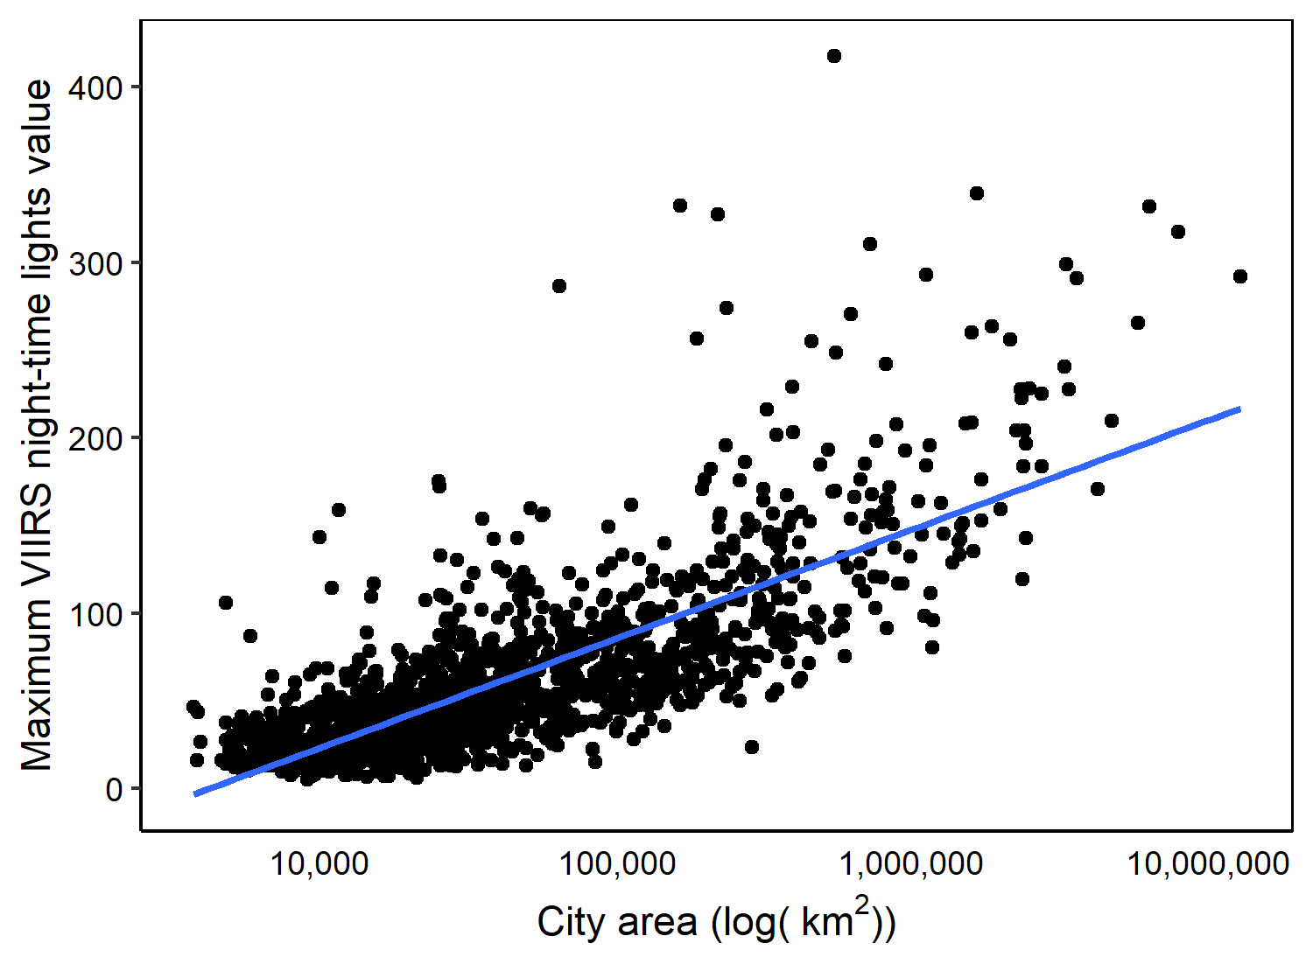

**Figure A3**. There was a positive relationship between city area and maximum VIIRS night-time lights value, suggesting that larger cities are potentially more likely to have a negative impact on biodiversity as they are more likely to reach the threshold of urbanization which significantly impacts biodiversity negatively.

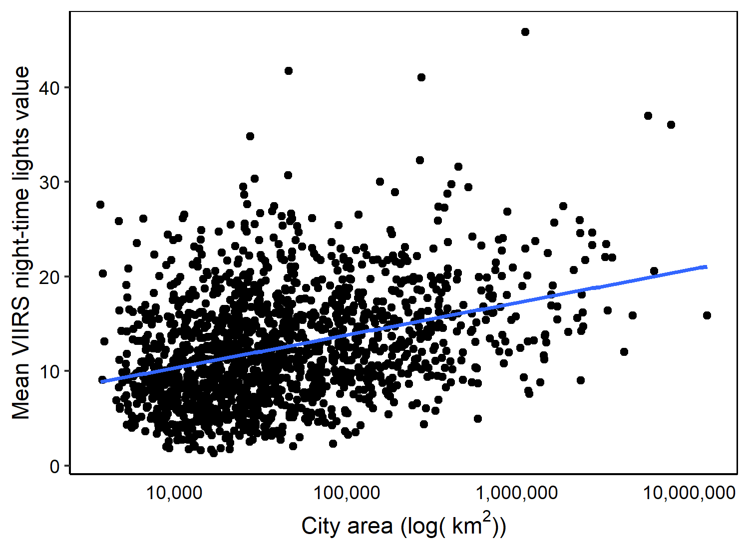

**Figure A4**. There was a slight positive relationship between city area and mean VIIRS night-time lights value, compared with maximum VIIRS night-time lights values (Figure A3 above).

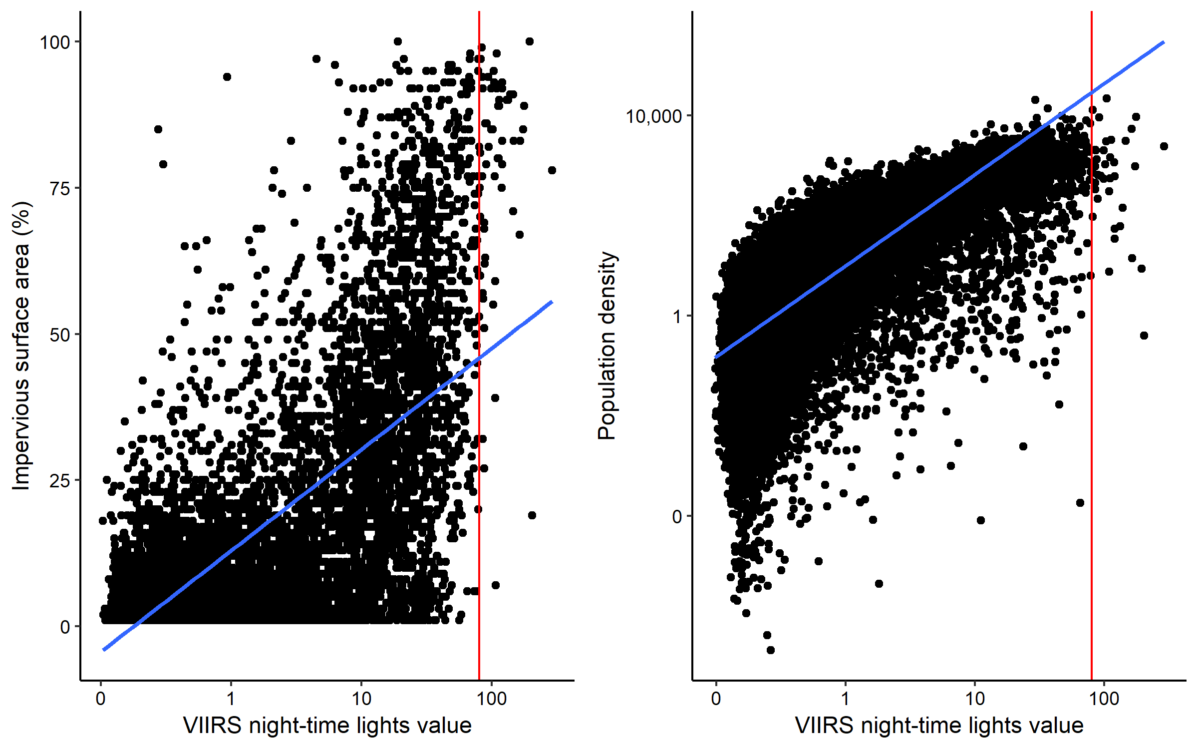

**Figure A5**. We randomly sampled 50,000 points throughout the contiguous United States and calculated (1) VIIRS night-time lights value (<https://doi.org/10.1080/01431161.2017.1342050>) as used in our study, (2) human population density per 1km2 (<https://doi.org/10.7927/H4F47M65>), and (3) the impervious surface area at 30m2 (<https://doi.org/10.1016/j.isprsjprs.2018.09.006>). The red line represents the approximate threshold we found in our main analysis (~80 radiance; Figure 4 in main manuscript). This roughly correlated with an impervious surface of ~50% and a human population density of ~10,000. “Zeros” were removed from the plot for both impervious surface and human population density, leaving us with sample sizes of 8,527 and 50,000 respectively.